CS 1632 - DELIVERABLE 3: Automated System Testing of a Web Application

Collin Dreher

cdreher

https://github.com/cdreher/D3

**Issues**

During this deliverable, most of my issues came from the URL routing. I was having issues figuring out what page to specifically direct to depending on the requirements. I felt the best way was to have a such “display” page in which all of the display results would go to, unless there was an error or invalid parameter. In those cases, I would direct to the appropriate page.

Another difficulty I had was at the very beginning of the project. When I was trying to execute ruby truth.rb, I was getting an interesting error. For some reason, I was getting an error with regards to the sinatra/reloader. The way I was able to fix that was to install an additional gem.

When it came to the Katalon testing, I did not have any issues or any failed tests. The tests were simple to make based off of the requirements page.

**Screenshot:**

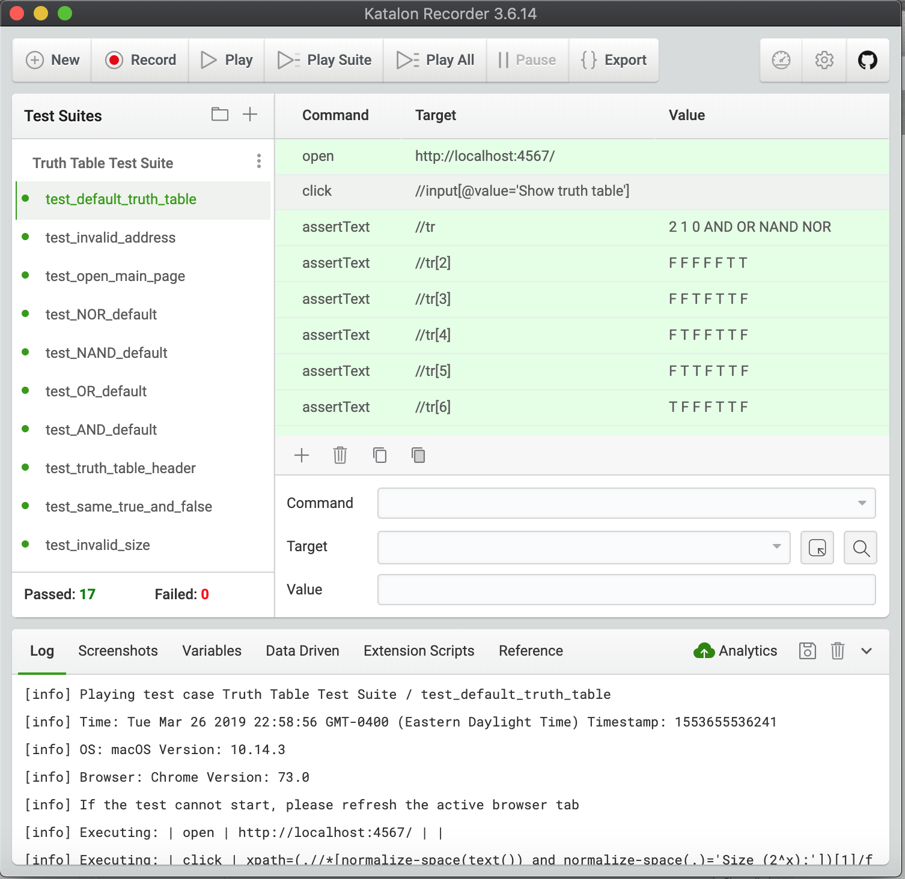

**Traceability Matrix:**

R1: *test_open_main_page*

R2: *test_reload, test_back_to_main_display, test_back_to_main_error, test_back_to_main_invalid*

*R3: test_invalid_page*

R4: *test_same_true_and_false, test_invalid_size, test_invalid_true_symbol, test_invalid_false_symbol*

R5: *test_truth_table_header*

R6: *test_AND_default, test_OR_default, test_NAND_default, test_NOR_default*

R7: *test_default_truth_table*

R8: *test_invalid_address*